Schedule

All talks and coffee breaks take place in MALL (8.02) School of Maths
Wine reception takes place in Reading room on 9th floor (across 9.25)

Monday
9:30 Registration
10:00 Martin Bays
11:00 Coffee break
11:30 Mervyn Tong
12:30 Lunch break
14:00 Mira Tartarotti
14:30 Melissa Ozsahakyan
15:00 Coffee break
16:00 Amador Martin-Pizarro (joint with Pure Maths Colloquium)
17:00 Wine reception

Tuesday
10:30 Coffee
11:00 Alex Berenstein
12:00 Evgueni Vassiliev
12:30 Lunch break
14:00 Assaf Hasson
15:00 Coffee break
15:30 Yilong Zhang
16:00 Philipp Hieronymi

Wednesday
10:00 Francoise Point
11:00 Coffee break
11:30 Wieslaw Pawłucki
12:30 Lunch break
14:00 Ebru Nayir
14:30 Ben de Smet
15:00 Duarte Costa
15:30 Coffee break
16:00 Erik Walsberg (joint with Logic Seminar)
19:00 Workshop dinner (Bengal Brasserie)

Thursday
10:00 Coffee
10:30 Jan Dobrowolski
11:30 Omar Leon Sanchez
12:00 Lunch break
14:00 David Smith
14:30 Xiaoduo Wang
15:00 Coffee break
15:30 Angus Matthews
15:30 Elliot Kaplan

Abstracts

Martin Bays (Oxford)
Title: Groups from non-expansion in higher dimension

Abstract: Call a complex polynomial f(x,y) expanding if there is e>0 such that for all sufficiently large finite sets A and B of complex numbers with |B| >= |A|, we have
|f(A,B)| > |A|^{1+e}. A result of Elekes and Rónyai shows that the only non-expanding polynomials f(x,y) are those obtained from addition or multiplication by composing with unary polynomials. Thinking of B as parametrising a family of unary polynomials
f_b(x)= f(x,b), we can see this conclusion as placing B in an algebraic group acting via f. Generalising in these terms, arbitrary nilpotent algebraic groups and their actions can arise. I will review some results indicating that this should be the most general situation, including work of Tingxiang Zou and myself which confirms this in certain cases, using methods from model theory and from additive and incidence combinatorics.

Alex Bernestein (Los Andes)
Title: Linearity and its equivalences in quasiminimal pregeometry structures.

Abstract: We give an introduction to the notion of linearity in the setting of strongly minimal theories and its generalization to geometric theories. Finally, we introduce the setting of quasiminimal pregeometry structures and the different characterizations of linearity in this setting. This is joint work with Evgueni Vassiliev.

Duarte Costa (Lisbon)
Title: Conic o-minimal sheaves
Abstract: In this talk, I will introduce and discuss conic o-minimal sheaves, which is on-going work with Mário Edmundo and Luca Prelli. This is an adaptation of the classical sheaf-theoretic notion of conic sheaves (developed mainly by Masaki Kashiwara and Pierre Schapira; see [1]) to the o-minimal context, where the focus shifts to definable (with parameters) sets over an o-minimal structure. Previously, it has been adapted to a subanalytic context (where the discussion is restricted to subanalytic sets) by Luca Prelli (in [2]). However, the adaptation of this concept to the o-minimal context has, somewhat surprisingly, been able to mirror the classical case more closely than the subanalytic case.

[1] - "Sheaves on Manifolds", Springer-Verlag, 1990, Masaki Kashiwara and Pierre Schapira.
[2] - "Microlocalization of subanalytic sheaves", Société mathématique de France, 2013, Luca Prelli.

Ben de Smet (Leeds)
Title: Homotopy Groups in O-minimal Structures

Abstract: In this talk I will discuss homotopy groups definable in the o-minimal setting. After giving a brief overview of the classical theory of homotopy groups, I will talk about previous results which have been proven in the o-minimal field case, before discussing my own work in the o-minimal linear case.

Jan Dobrowolski
Title: Model theory of existentially closed ordered real vector spaces with an automorphism.

Abstract: Until recently, model theoretic study of automorphisms (say σ) of ordered abelian groups had been confined to the case where σ-Id has constant sign on the whole group (notably, in the work by Laskowski and Pal). In 2023, with R. Mennuni we have proved that the classes of ordered abelian groups with an automorphism and ordered real vector spaces with an automorphism have the Amalgamation Property, and deduced they are NIP in the sense of Robinson/positive logic. After introducing the above-mentioned context, I will report on a work in progress aiming at understanding the first-order theory of existentially closed models in the these classes, based on the idea of W. Johnson of adding a natural valuation and predicates describing the behaviour of the automorphism in order to obtain quantifier elimination. The main result is that the common theory of existentially closed ordered real vector spaces with an automorphism is complete and NIP. Time permitting, I will discuss potential connections to valued difference fields of residual characteristic 0.

Assaf Hasson (Ben Gurion)
Title: topologically 1-based structures.

Abstract: We define the notion of a topologically 1-based structure, adapting the analogous stability theoretic concept in the setting of t-minimal structures with the independent neighbourhood property. For geometric t-minimal structures, topological 1-basedness coincides with weak 1-basedness (studied by Bernstein and Vassiliev). We prove that non-trivial topologically 1-based structures admit a type-definable topological group that is locally linear (in an appropriate sense) and locally abelian. These results apply, in particular, to dense C-minimal structures, and to densely ordered weakly o-minimal theories.

Joint work with Ben Castle.

Philipp Hieronymi (Bonn)
Title: d-minimal cell decomposition
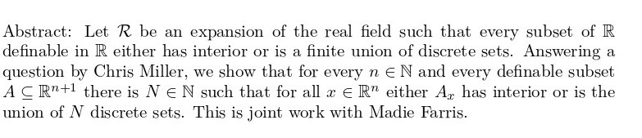
Elliot Kaplan (Mons)
Title: New developments on algebraically bounded theories with generic derivations

Abstract: Let T be an extension of the theory of fields of characteristic zero, and suppose that model-theoretic and field-theoretic algebraic closure coincide in every model of T (i.e. T is algebraically bounded). Fornasiero and Terzo proved that if one expands models of T by a derivation (or by several derivations, either commuting or non-commuting), the resulting theory has a model completion. Since then, a number of authors have investigated how much the model theory of this model completion is controlled by that of T. Recent work includes the transfer of combinatorial tameness properties, the behavior of independence relations, bounds on ranks, and descriptions of definable sets, groups, and fields. In this talk, I will survey several of these developments, along with some connections to the differentially large fields studied by León Sánchez and Tressl.

Omar Leon Sanchez (Manchester)
Title: Some model-complete theories of differential fields in positive characteristic.

Abstract: I will discuss a phenomenon that occurs in some differential fields of positive characteristic and some of the model-theoretic properties that can be obtained in this setup.

Amador Martin-Pizarro (Freiburg)
Title: Some alternative proofs in ergodic theory using model-theory.

Abstract: Many proofs in additive combinatorics regarding the structure of subsets of positive upper (Banach) density have been successfully solved using techniques and methods from ergodic theory. In this talk we will present ongoing work with Daniel Palacín (Madrid) on how to tackle some variations of these statements using model-theory as an alternative approach.

Angus Matthews (Leeds)
Title: Geometric theories of fields

Abstract: A theory expanding the theory of fields is geometric if acl satisfies the exchange property and it eliminates 'there exist infinitely many'. Many classical theories of fields are geometric, for instance o-minimal theories, ACVF, and the expansion of ACF by a generic predicate. Our main result is:
Theorem A: Given a geometric theory of fields T
- If T is stable, it is strongly minimal.
- If T is simple, it is supersimple of SU-rank 1.
- If T is rosy, it is superrosy of thorn-rank 1.
We will briefly overview the proof and discuss implications.

Joint work with Antongiulio Fornasiero and Elliot Kaplan.

Ebru Nayir (Istanbul)
Title: VC-density in pairs of ordered vector spaces

Abstract. In this talk, I will outline the proof that, in dense pairs of ordered vector
spaces, the VC-density of any partitioned formula is bounded above by twice the number of parameter variables. I will also show that this bound is optimal. This is joint work with Ayhan Gunaydin.

Melissa Ozsahakyan (Istanbul/Imperial)
Title: Distality of oriented abelian groups and their pairs.

Abstract: In this talk, we introduce oriented abelian groups and present several tame-
ness results for these structures and their pairs, including VC calculations,
dp-minimality, and NIP. We then present our main results on distality: oriented abelian groups are distal, while pairs of these groups are not. This is ongoing joint work with Charlotte Kestner.

Wiesław Pawłucki (Krakow)
Title: Strict C^p-triangulations - a new approach to desingularization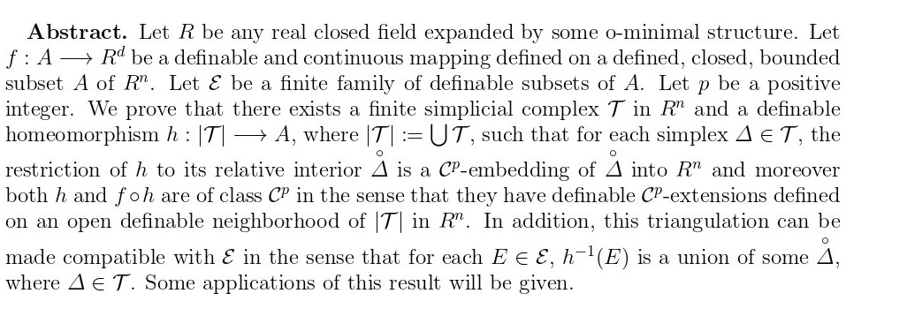

Francoise Point (Paris)
Title: Dense pairs of rings

Abstract: Outside of the framework of geometric theories, we exhibit complete, respectively model-complete theories of rings whose corresponding theory of pairs is complete, respectively model-complete, using transfer results proven for boolean products of structures. It includes certain boolean products of pairs of dp-minimal fields of characteristic 0. We show, as in the case of certain dense pairs of fields, how it fits in the framework of differential rings. Finally, we consider two other properties: the open core property and elimination of imaginaries.

David Smith (Manchester)
Title: Zilber-Pink for geometrically generic varieties in multiplicative groups

Abstract: The Zilber-Pink conjecture is a central conjecture in Diophantine geometry predicting that "unlikely intersections" between an algebraic variety and certain special subvarieties occur only for structural reasons arising from their ambient space. Model theory, in particular, has played a central role in establishing significant cases of this conjecture.

In 2025, inspired by model-theoretic and differential-algebraic ideas of Pila and Scanlon, Aslanyan, Eterović and Fowler proved that Zilber-Pink holds for all subvarieties V of ℂ^N for which no projection to any dim V + 2 coordinates is defined over the algebraic numbers.

In this talk, I will discuss work in progress proving an analogue of this result in the case of algebraic tori and outline the similar model-theoretic approach involved.
Mira Tartarotti (Oxford)
Title: Relative distality and incidence bounds in valued fields with finite residue field

Abstract: The class of so-called distal theories was isolated by Simon as a class of purely unstable NIP theories. Examples include all o-minimal theories and the theory of the p-adics. A rare natural example of an NIP theory that is neither stable nor distal is the theory of algebraically closed valued fields (ACVF), which interprets an o-minimal part (the value group) and a stable part (the residue field). We introduce the notion of relative distality and show that ACVF is distal relative to the residue field. As an application, we strengthen a result of Bays and Martin by proving that valued fields with finite residue field uniformly satisfy incidence bounds in the sense of the Szemerédi-Trotter Theorem. The argument relies on distal incidence bounds due to Chernikov, Galvin, and Starchenko.

Mervyn Tong (Cambridge)
Title: Higher-arity distality and hypergraph regularity

Abstract: In recent years, the intersection of model theory and combinatorics has been a fertile ground for research. One notable example concerns the Szemerédi regularity lemma, a pivotal result in combinatorics that allows graphs to be decomposed into a bounded number of mostly uniform parts. Chernikov and Starchenko showed that if the graph is definable in a distal structure, then it satisfies an improved version of the Szemerédi regularity lemma.

It often happens in maths that some theory is first developed in two dimensions, and finding the correct extension to n dimensions is as hard as doing so for 3 dimensions. This is well exemplified in the history of hypergraph regularity lemmas. We will give an overview of the key features and difficulties in finding a 3-uniform hypergraph extension of the Szemerédi regularity lemma, before discussing our extension of Chernikov and Starchenko's result to hypergraphs definable in structures satisfying a certain notion of higher-arity distality. We will highlight a key innovation required for the proof, namely, higher-arity strong honest definitions that we develop for this notion of higher-arity distality.

Evgueni Vassiliev (Newfoundland)
Title: Homogeneity and local boundedness in pairs of geometric structures.

Abstract: Dense–codense pairs of geometric structures give rise to the small closure (scl), the localization of the algebraic closure at the smaller model. This can be viewed as a way of capturing the underlying geometry of the structure. For example, in the linear non-trivial case, it allows one to recover a vector space geometry. I will discuss the connection between linearity and the local boundedness of scl, as well as some properties of scl in the general geometric case that typically appear in classical strongly minimal structures. This is a joint work with Alexander Berenstein.

Erk Walsberg (Vienna)
Title: The model theory of large fields.

Abstract: Large fields are an interesting class of fields first introduced by Pop in the 90's for Galois-theoretic reasons. They have subsequently been studied for a variety of reasons. As logicians we are interested in large fields because essentially all known logically tame fields are large. I will discuss recent work on the model theory of large fields, joint with Will Johnson, Chieu-Minh Tran, and JInhe Ye. Only minimal background in algebra will be assumed.

Xiaoduo Wang (Manchester)
Title: Curve Selection and Delta-Topology on Closed Ordered Differential Fields

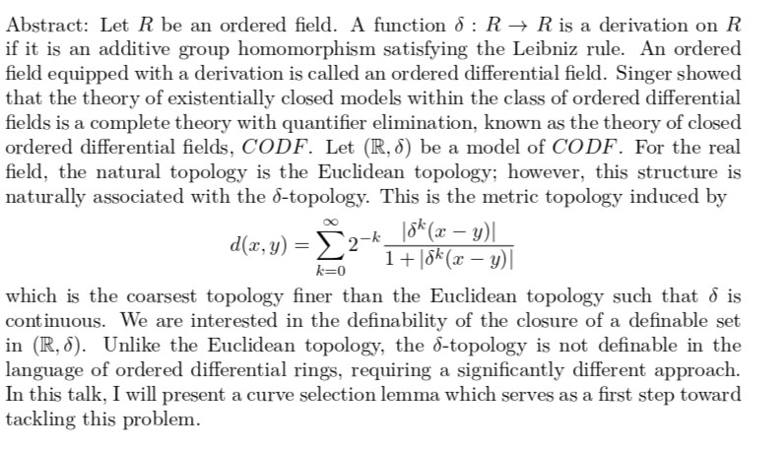
Yilong Zhang (Bonn)
Title: Hrushovski construction in ordered fields

Abstract: I will present my attempt to apply the Hrushovski construction to ordered fields. I will introduce my result on the real field with dense logarithmic spirals. I will focus on my recent progress on powered fields, an expansion of RCF by "power functions" on the unit circle, which gives an axiomatization of the corresponding expansion of the real field.

